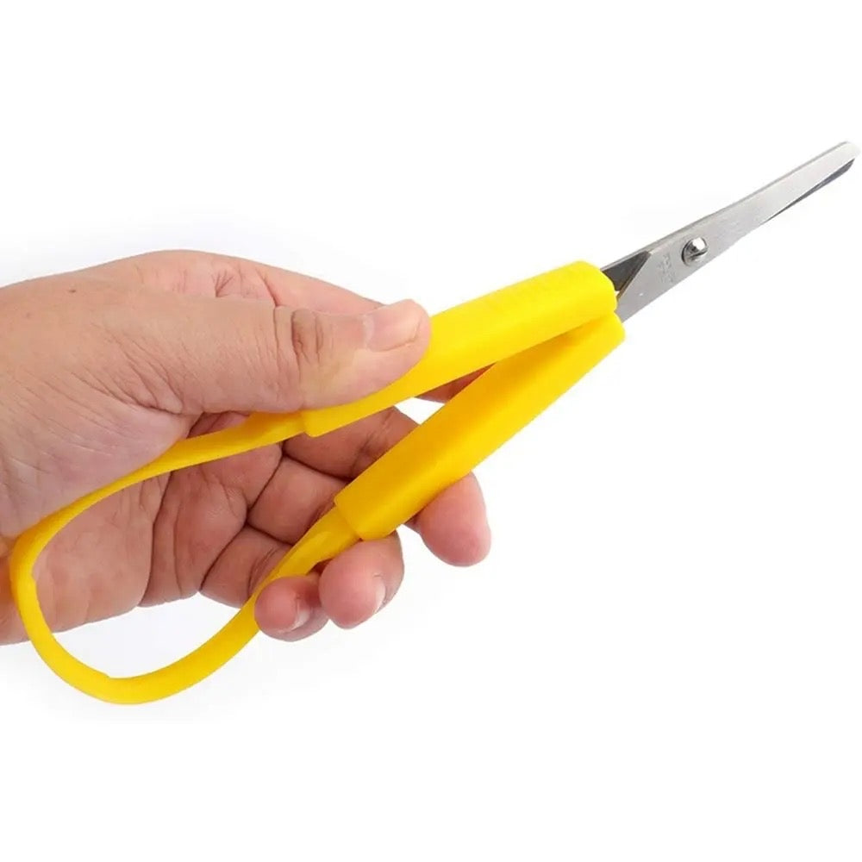
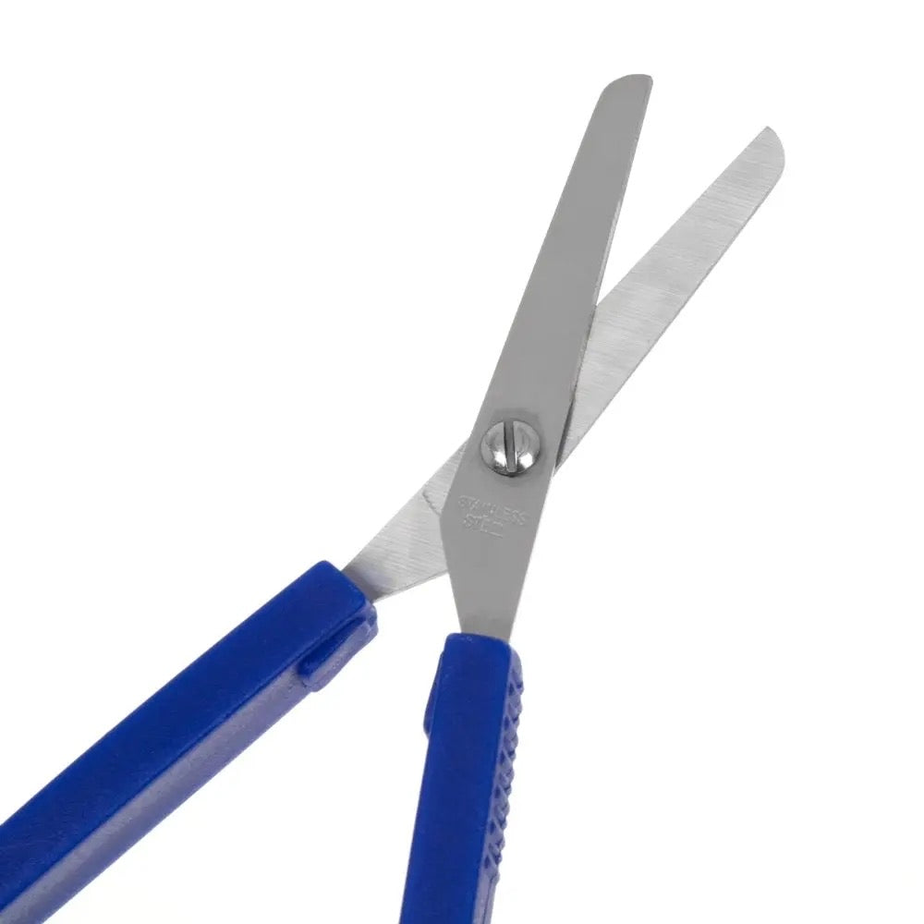
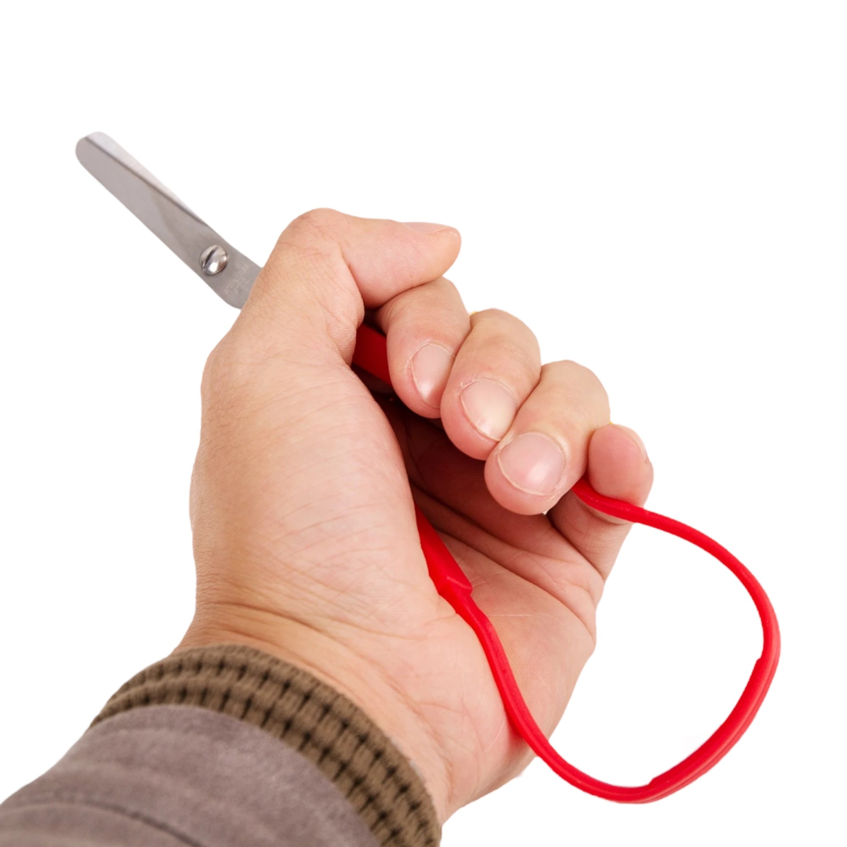
  - SELF OPENING SCISSORS

Description:
Self opening loop scissors are designed to make cutting easier and more comfortable, helping reduce the effort needed to open and close the blades. The loop handle automatically springs the blades back open after each cut, so you only need to squeeze to continue cutting.
Instead of traditional finger holes, the loop design supports a natural squeeze motion that can feel easier for many hands. These scissors are often used in classrooms, therapy settings, and craft spaces where extra support with cutting can make a real difference. They are lightweight, easy to control, and suitable for both left and right handed users.
Whether it’s arts and crafts, school projects, therapy activities, or everyday tasks, these loop scissors are a simple tool that can help make cutting feel more manageable and enjoyable.

Great for:
✂️ Children learning early scissor skills and building confidence with cutting
🏫 Classrooms and learning environments where supportive tools help students participate
🧠 Occupational therapy and hand therapy activities that support coordination and control
🖐️ People working on grip strength, hand control, or fine motor skills
🎨 Arts, crafts, paper cutting, and creative projects
🧵 Craft spaces, hobby groups, and creative activities at home
🧓 Older adults who find traditional scissors harder to manage
💪 Rehab or recovery where practicing cutting movements helps rebuild strength and coordination
📚 Therapy sessions where repeated cutting movements are part of skill development
🖥️ Everyday cutting tasks at home, school, or work

Features:
🔁 Self opening loop handle that automatically reopens after each cut
🖐️ Easy squeeze design that reduces effort and hand fatigue
🪶 Lightweight construction for comfortable use
↔️ Suitable for both left and right handed users
📚 Helpful in classrooms, therapy environments, and craft spaces

Detail:
Material: Plastic, Stainless Steel
Size: 13.5cm (L)
Weight: 15 grams
Package Contains: 1x Accessible Scissors
Age Guidance: Suitable for ages 3+. Supervision recommended for younger users.

How to Use:
🖐️ Hold the loop handle comfortably in your hand
✂️ Gently squeeze the loop to close the blades and make a cut
🔁 Release pressure and the blades will reopen automatically
📄 Repeat the motion to continue cutting

Care Instructions:
🧼 Wipe clean with a soft damp cloth if needed
🌬️ Dry before storing

Safety Information:
⚠️ Use with supervision for younger children
⚠️ Not intended for heavy duty cutting tasks
⚠️ Store safely out of reach of small children when not in use

